# Data Modelling Task

Here is a typical business model:

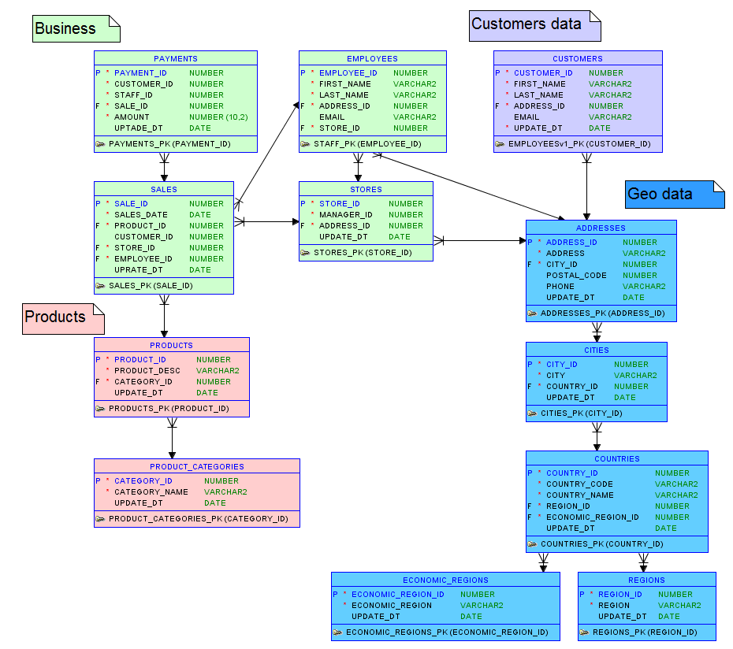

# Four-Step Dimensional Design Process

## Step 1: Select the Business Process

A business process is a low-level activity performed by an organization. In this situation activity is sales processing.

**Step 2: Declare the Grain**

One row of sales for each customer per each product, from every store, for some date, organized by each employee

## Step 3: Identify the Dimensions

Dimensions are: Customer, Date, Product, Employee, Store.

## Step 4: Identify the Facts

Fact is Sales

* 1. **Star Schema:** 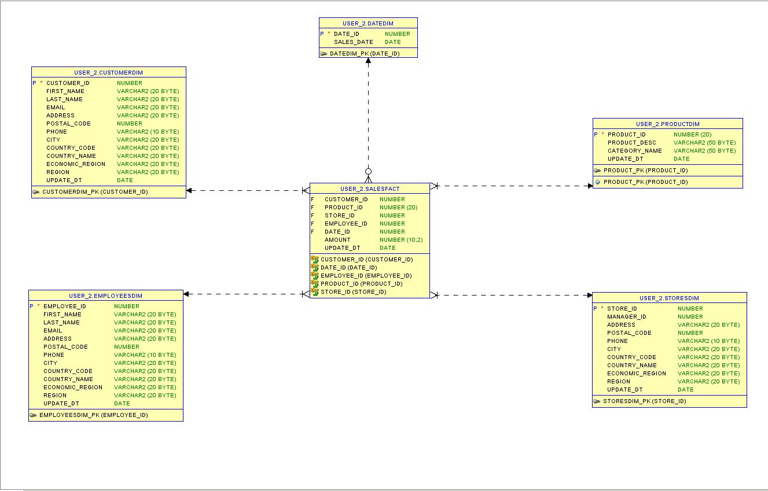
  2. **Snowflake Schema:**

Bus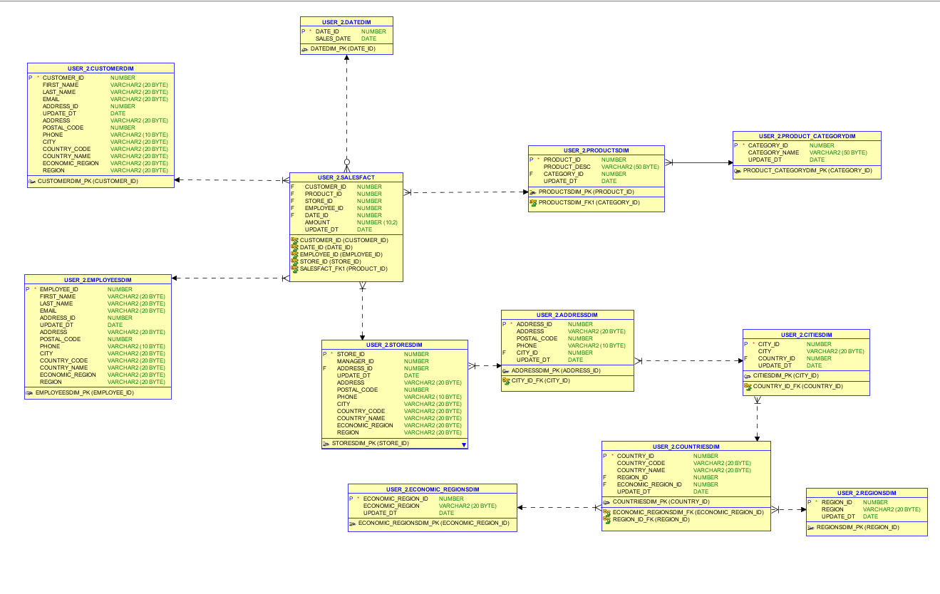

**Business Description**

## Business background

The “Gold’s Gym” company provides gym services (cardio-zone, weight zone). This gym has come popular in 70’s and becoming more and more popular nowadays.

## Problems because of poor data management

The main aim is to find out target audience for this gym, understand that does company needs to enrich their range of equipment and range of products.

## Benefits from implementing a Data Warehouse

Increment of gym activity, sales growth, understand the needs of some equipment and its enrichment.

(this theme is not final)